Hibernia Summer Events in July!

Master level 1-10 Saturday 7th and Sunday 8th July

I’ll be leading a Master level 1-10 over Saturday 7th and Sunday 8th July. This will be a special event for players that loved ToA back in the day and want to do this for good old memories in DAoC.

Details are below on what steps we’re be doing (Battlegroup Steps only)

Saturday 7th July Battlegroup Master level 1-6

Starting at: 8PM CET / 7PM UK / 2PM EST / 1PM CST / 11AM PST
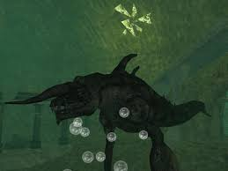
Master level 1
1.6 - Kirk, Curses
1.4 – Barrier
1.7 - Rassa
1.9 - Harpies, The Crown
1.8 - Azures and Rubies
1.3 - Chiefs
1.10 - Cetus

Master level 2
2.3 - Triton Hoards
2.1 - Death from Shadow
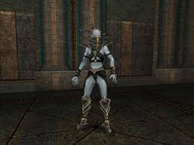2.2 - Stalking Terror
2.4 – Rrionne’s Reflection
2.9 – Battle Masters
2.6 – Kanahkt Test
2.10 – Immortal Imposter

Master level 3
3.1 – Moirai’s Destruction
3.6 – Glowing Barracuda’s Fading
3.8 – Sting Ray’s Power Absorbed
3.9 - Sinvoia’s Power Relinquished
3.2 – Kepa’s Downfall
3.3 – Casta’s Annilihation
3.1 – farm for eggs
3.5 - Antioos
3.4 – Laodamedia’s Furious End
3.10 – Medusa
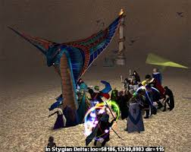

Master level 4
4.2 – Fortress of Storms
4.5 – Jann
4.6 – Oukesson
4.7 – Iter Statues
4.8 – Daehien
4.9 – Gaurmaes
4.10 – Matikhoras

Master level 5
5.10 – Ammut’s Appetite

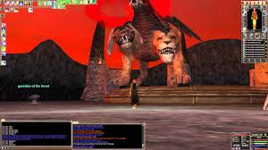Master level 6
6.4 – Pallida-uraei
6.2 – Sacrifice
6.6 – Siraadi
6.3 – Lateef
6.7 – Ankhkare
6.8 – Efreet
6.9 – Vazul
6.10 – Chimera

Sunday 8th July Battlegroup Master level 7-10
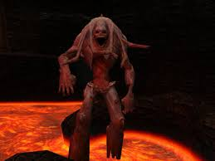
Start time: 8PM CET / 7PM UK / 2PM EST / 1PM CST / 11AM PST

Master level 7
7.7 - Chamber of the Flame
7.8 – Katorii
7.9 – Mysterious Force
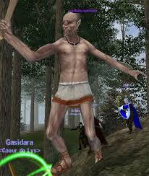7.10 – Typhon

Master level 8
8.6 – Head, Agne’s Will
8.1 – Agne’s Crystal
8.3 – Agne’s Sword
8.2 – Agne’s Shield
8.5 – Treasurer of the Cyclops
8.8 – Left Arm, Gorgon’s Secret
8.10 – Talos’s Temple, Agne’s Great Might

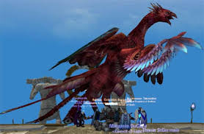Master level 9
9.1 - Kyros
9.5 – Nelos
9.6 – Katri
9.2 – Lachlen
9.3 – Evzen
9.7 – Iaculi
9.8 - Phoenix Guardians
9.4 – Kings’ Likenesses
9.9 – Neola
9.10 – Phoenix

Master level 10
- 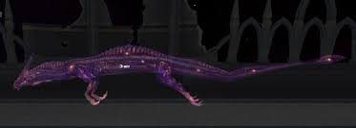Sagittarius
- Scorpius
- Centaurus
- Leo
- Draco

